**How to create a Kodi screenshot**

Run this command:

|  |
| --- |
| kodi-send --action="TakeScreenshot" |

Check the screenshot folder location here:

|  |
| --- |
| SYSTEM -> Settings -> System -> Debugging -> Screenshot folder |

I set this to “/storage/screenshots”.  
  
My genrated capture file was around 2Mb.  
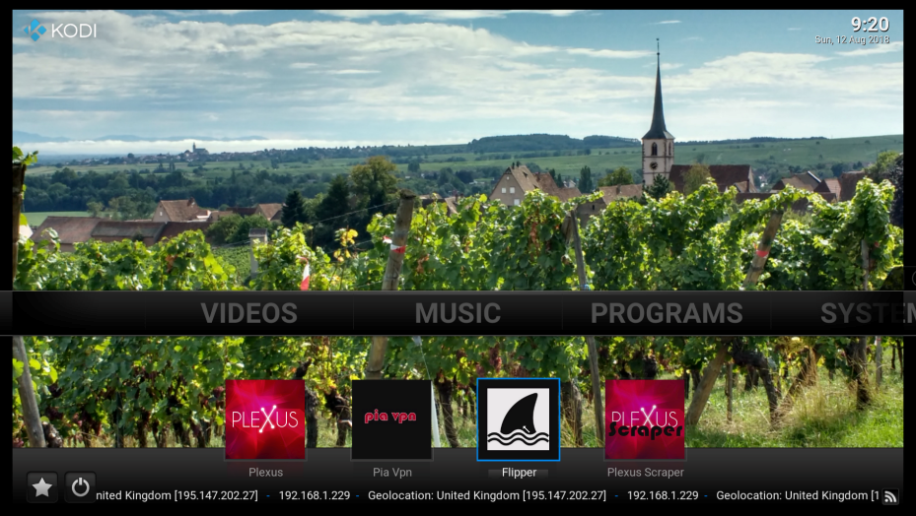  
  
  
**References:**<https://forum.kodi.tv/showthread.php?tid=258445>

*JeremyC 12-08-2018*